suspiro-trampa
December 5, 2024 – January 15 2025
Stefano Santa María, Cristóbal García Belmont
Text by Laura Rossini
SUSPIRO-TRAMPA is an exhibition featuring three video works and a a photograph by artist Stefano Santa María, as well as nine extended drawings, nine instant photographic prints, one sound installation, and a wall intervention with pencils by artist Cristóbal García Belmont. Additionally, philosopher and poet Laura Rossini contributed a poetic text to the exhibition.
Inspired by early 20th-century Surrealist poet Ghérasim Luca, who valued chance and automatism, SUSPIRO TRAMPA presents itself as a circuit transforming the trap into possibility, confinement into resonance, and closure into a sigh. Against the grand narrative of reason as a totalizing structure, the works invoke uncertainty, that which cannot be contained or defined—life as a constant act of renewal.
Cristóbal García Belmont (Lima, 1996) explores processes of sound via performance, sculpture, and poetry as they investigate the circulation of mediums and materials in complex postcolonial realities. By examining sound as a political phenomenon and considering sound and sculptural elements on an architectural scale, his work understands the repercussions of sound vibrating through material as a visual language. Cristóbal’s practice interrogates the capacity to appropriate existing infrastructures and create spaces where bodies and objects may resonate, triggering discussions about inherited power dynamics and proposing alternate ways of listening and imagining our surroundings. Lives and works in Madrid, Spain.
Stefano Santa María (Lima, 1996) revolves around what they describe as The Medium Image, a concept born from an interest in liminal spaces—those moments of transition and unease where reality feels fluid and on the brink of transformation. In these physical and symbolic thresholds, images are not merely static representations; they are living entities, shifting between states, crossing borders between the visible and the invisible, the tangible and the ethereal. Their aim is to capture this passage—this process of change that, though imperceptible to the naked eye, recurs throughout everyday experience. Lives and works in Madrid, Spain.

suspiro-trampa
December 5, 2024 – January 15 2025
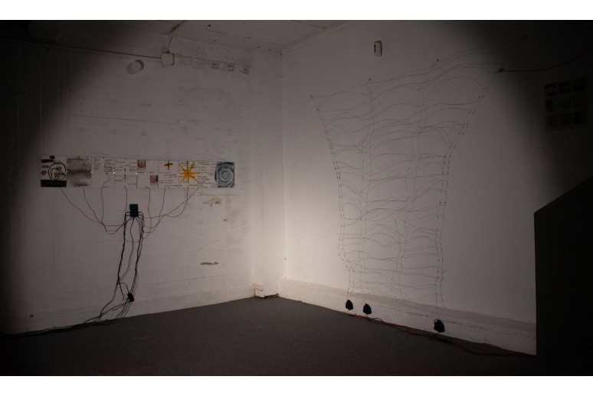
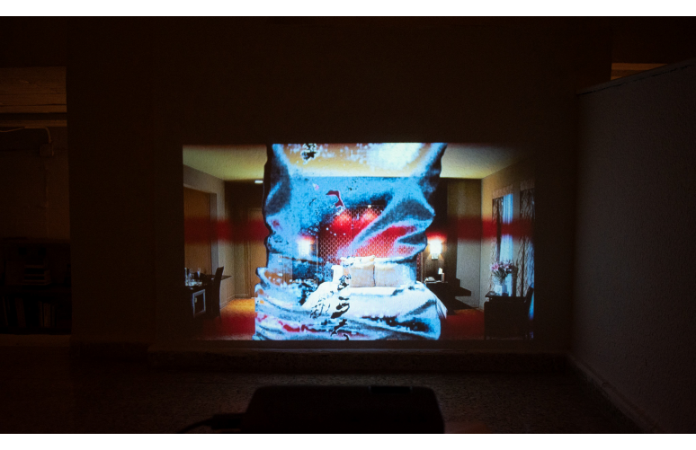
suspiro-trampa
December 5, 2024 – January 15 2025
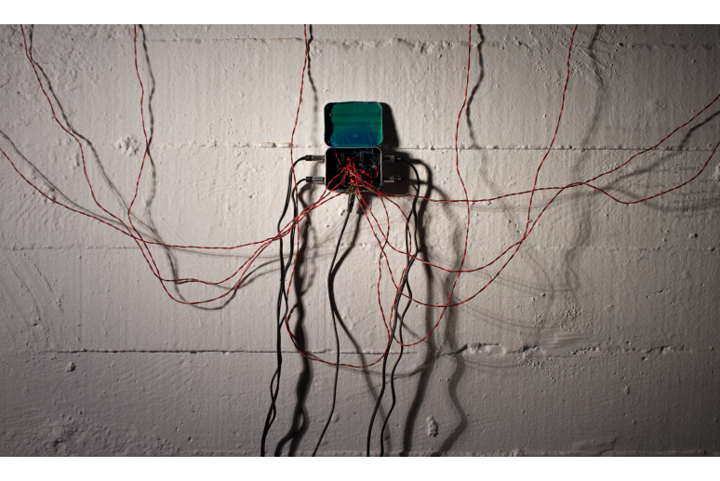
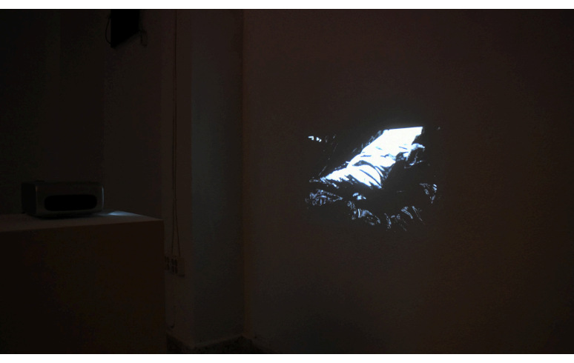
suspiro-trampa
December 5, 2024 – January 15 2025
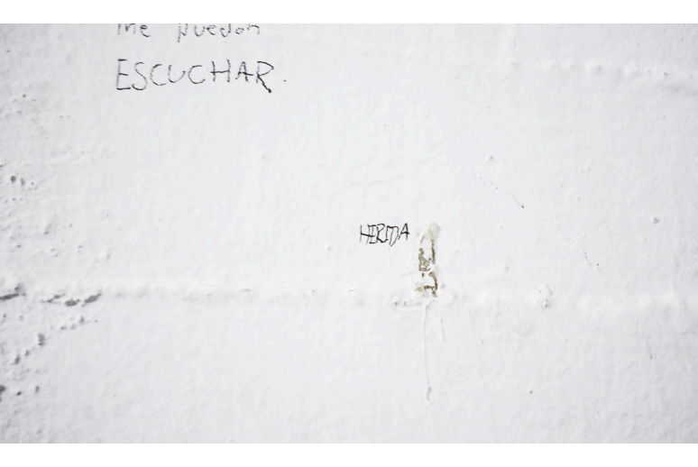
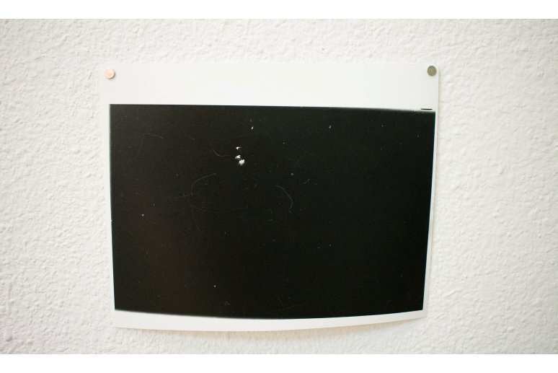
suspiro-trampa
December 5, 2024 – January 15 2025
suspiro-trampa
December 5, 2024 – January 15 2025
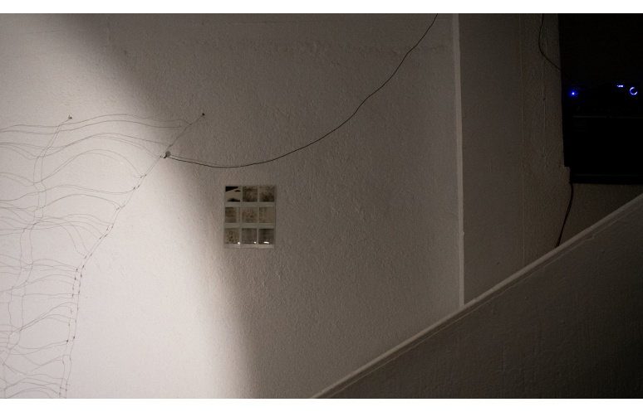
Listen
Haiku #94
Estudio de canción I-IX

